Help Sheet
Intermolecular Forces
&
Physical Properties of Solutions
Chapters 11 & 13

Intermolecular Forces

Dipole - Dipole
Ion – Dipole
Dispersion
Hydrogen Bonding (H-F, H-N, H-O)
Types of Crystals
Molecular, Ionic, Metallic, Covalent Network

Phase Changes
Water
If P⇑ Then FP⇓ and BP⇑

1 Increase
Pressure
P(atm)
S L S L

.006 G G

.01
0 100
T (ºC) T (ºC)

Carbon Dioxide

P(atm)
5.2

1

-78 -56
T (ºC)

Concentration

Percent

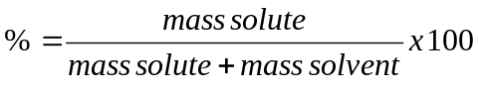

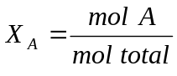 Mole Fraction

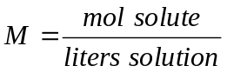 Molarity

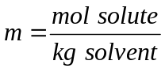 Molality

Colligative Properties

Vapor Pressure Lowering … if a solute is nonvolatile, the vapor pressure of its solution is always less than that of the pure substance.

Raoult’s Law … The relationship between solution vapor pressure and solvent vapor pressure depends on the concentration of the solute in the solution.

P₁ = X₁Pº

Boiling Point Elevation …
ΔT_{b} = k_{b}m

Freezing Point Depression …
ΔT_{f} = k_{f}m

Osmotic Pressure …
π = MRT

Electrolytes … Van’t Hoff factor (i)

ΔT_{b} = ik_{b}m

ΔT_{f} = ik_{f}m
π = iMRT

